**Flow Chart of PRAAN:**

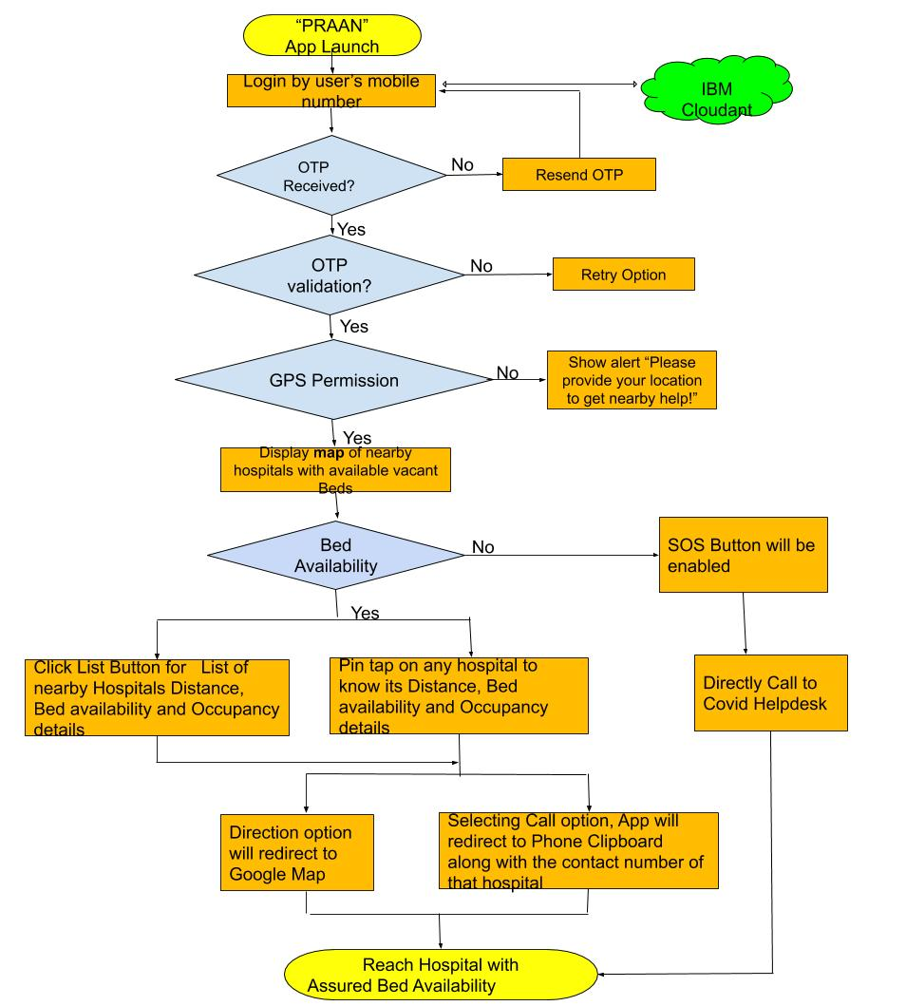

1. The user login to the app by simple mobile-OTP validation and give access to his/her GPS location.
2. IBM API connect used to fetch the data of nearby hospitals to the COVID patient.
3. HERE maps displays location-based nearby hospitals.
4. The user can toggle between map and list of hospitals collection.
5. The user can navigate to a detailed view of the hospital by tapping on the corresponding pin on map or by selecting it from the list view.
6. Watson Translation (optionally) can translate the text to the desired language.
7. The user can view images of the hospital, estimated distance from his current location, pricing/bed, available and filled beds/ventilators.
8. The user can also call and get directions on map to the hospital selected while approaching the same.